**DOKUZ EYLUL UNIVERCITY**

**EEE**

**İNTRODUCTİON TO PROGRAMING**

NAME : Yavuz BALI

NO : 2014502021

**Laboratory Study:**

**Task 1:**

#include<stdio.h>

#include<stdlib.h>

int main()

{

int person_1,person_2,person_3,person_4,person_5,average;

printf("please enter salary of person_1>");

scanf("%d",&person_1);

printf("please enter salary of person_2>");

scanf("%d",&person_2);

printf("please enter salary of person_3>");

scanf("%d",&person_3);

printf("please enter salary of person_4>");

scanf("%d",&person_4);

printf("please enter salary of person_5>");

scanf("%d",&person_5);

average=(person_1+person_2+person_3+person_4+person_5)/5;

printf("person_1 has %s salary\n",average<=person_1?"Good":"Bad");

printf("person_1 has %s salary\n",average<=person_2?"Good":"Bad");

printf("person_1 has %s salary\n",average<=person_3?"Good":"Bad");

printf("person_1 has %s salary\n",average<=person_4?"Good":"Bad");

printf("person_1 has %s salary\n",average<=person_5?"Good":"Bad");

}

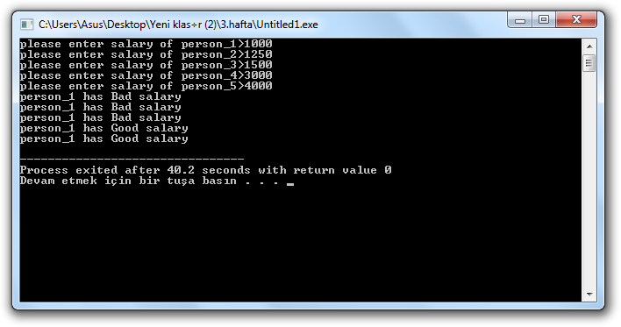

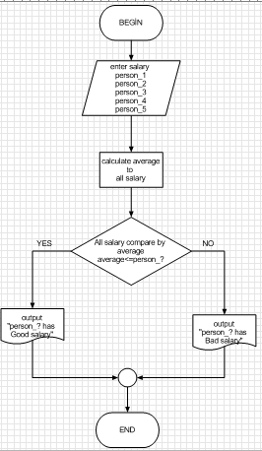

**Task 2:**

**#include<stdio.h>**

**#include<stdlib.h>**

**int main()**

**{ int c=1,b;**

**float a=0,H;**

**while(c<=5)**

**{ printf("Please enter number_%d >",c);**

**scanf("%d",&b);**

**c=c+1;**

**a=a+(1.0/(float)b); }**

**H=5/a;**

**printf("Harmonic mean = %.3f",H); }**

